

THE ROVER



Project Increment-1

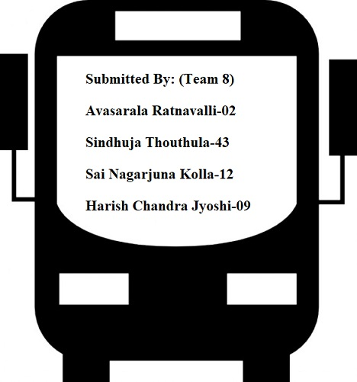

**1.Introduction:**

**2. Project Goal and Objectives:**

**2.1 Motivation:**

To provide the travel assistance to travellers in planning the tour, acquiring accommodation and the transportation facilities and also to overcome the difficulties faced by them like the language barrier and the restaurant/food availabilities, search for the tourist attractions has motivated us to develop an app with all the requirements integrated with augmented Reality, which would help them to give a best travel experience.

**2.2 Significance/uniqueness:**

This system has all the travel support and guidance options with augmented reality feature integrated in a single platform.

**2.3 Objective:**

Our idea is to develop a web application for a particular tourist attraction and implement augmented reality on it for a better tourist experience by integrating various facilities on a single platform.

2.4 **System Features:**

* The user can login using any social networking sites like google or facebook or create an account and get assistance about the places he is planning to have a tour.
* Using Augmented Reality get the instant Text Translation of any text to their native languages.
* Acquire the shortest distance suggestions, Transportation facilities available, estimated time of reaching and the nearby restaurants and the accommodations along their way to destination.
* Gets to know the historical and the cultural information of a monument or a place and also how would they appear in a different season or in the past years.
* Travellers will never get bored during their long drives by playing educational games about their destinations.
* Obtain the weather Forecast even before reaching the destination in an interactive way with augmented reality feature.

**3. First Increment report:**

* 1. **REST Services:**
     + - Google Maps API
       - OpenWeatherMap API.
       - Knowledge Graph Search API
  2. **Detailed Design of Features**
* **Wireframes:**

**\*\*INSERT WIREFRAMES HERE\*\***

* **Architecture Diagram:**

**\*\*Insert architecture diagram\*\***

* **Sequence Diagram:**

**Sequence diagram of User Register and Login**

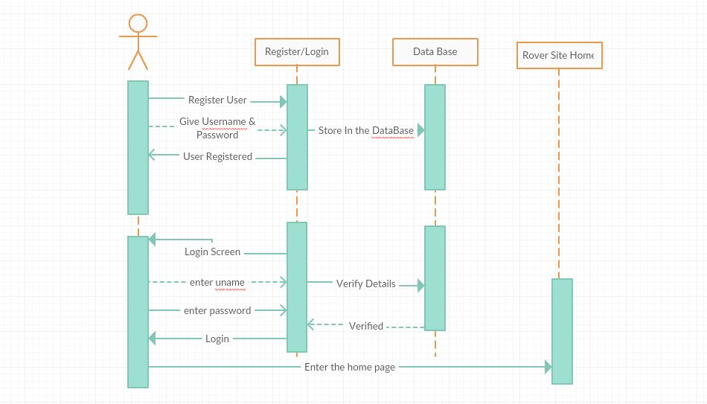

**Class Diagram:**

**\*Include Class diagram\***

* 1. **Testing:**

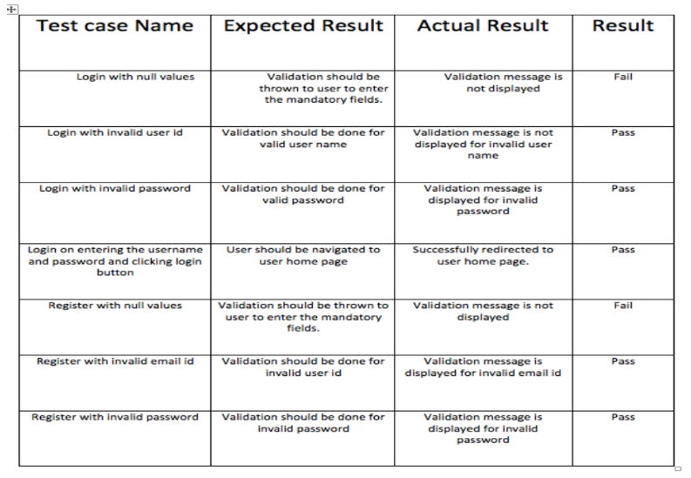

* 1. **Implementations:**

**Screenshots of the Web application:**

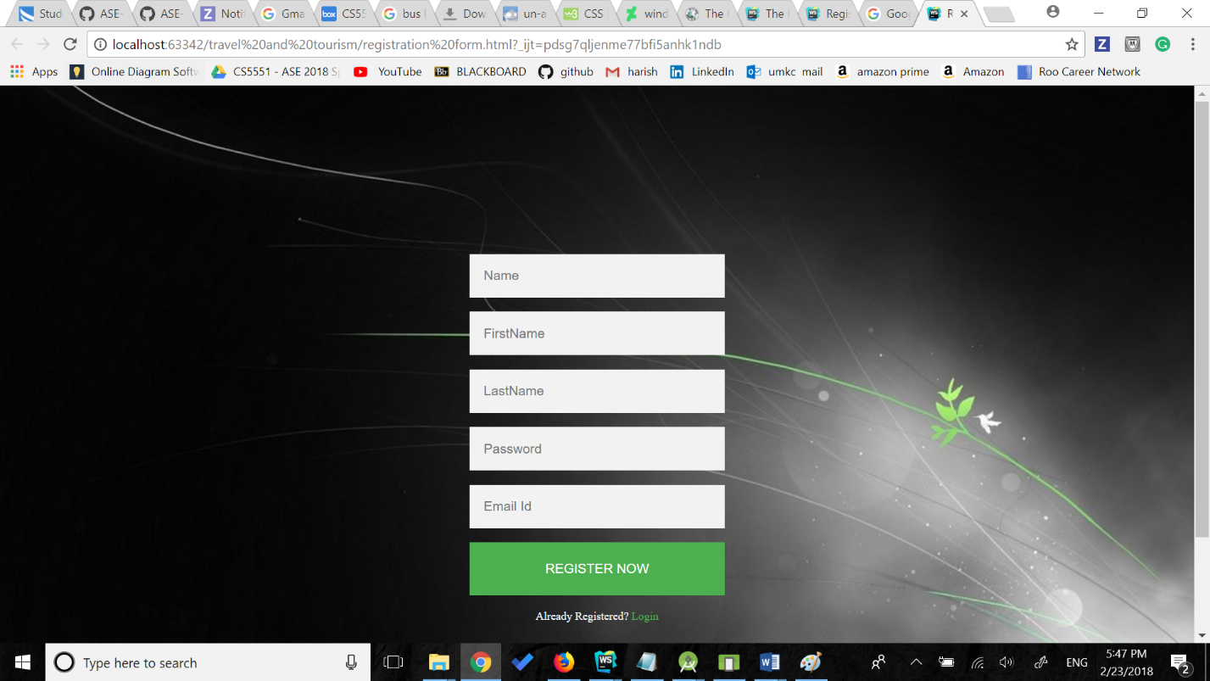

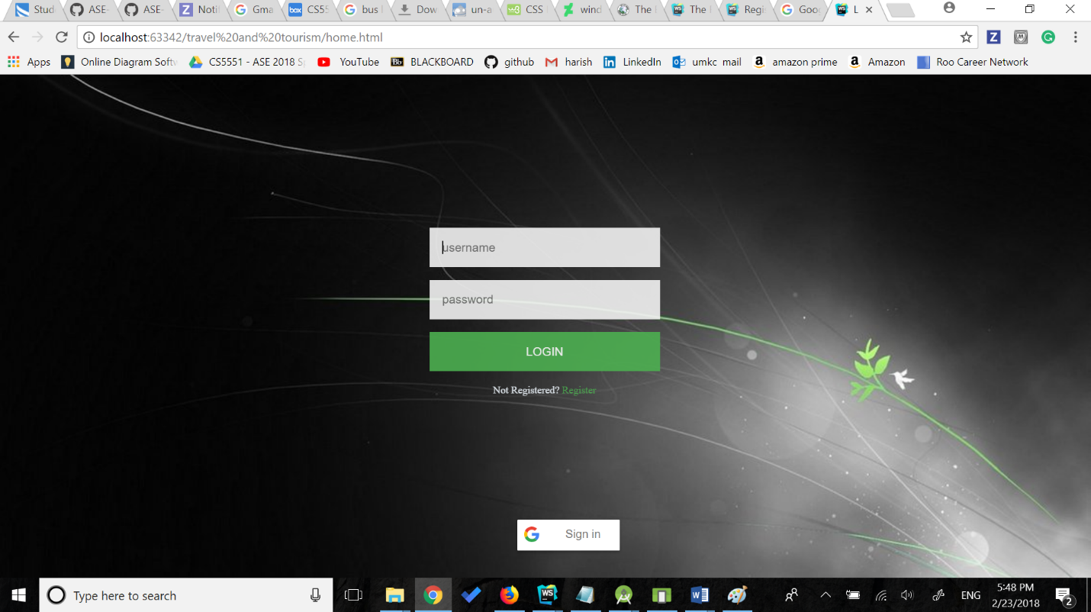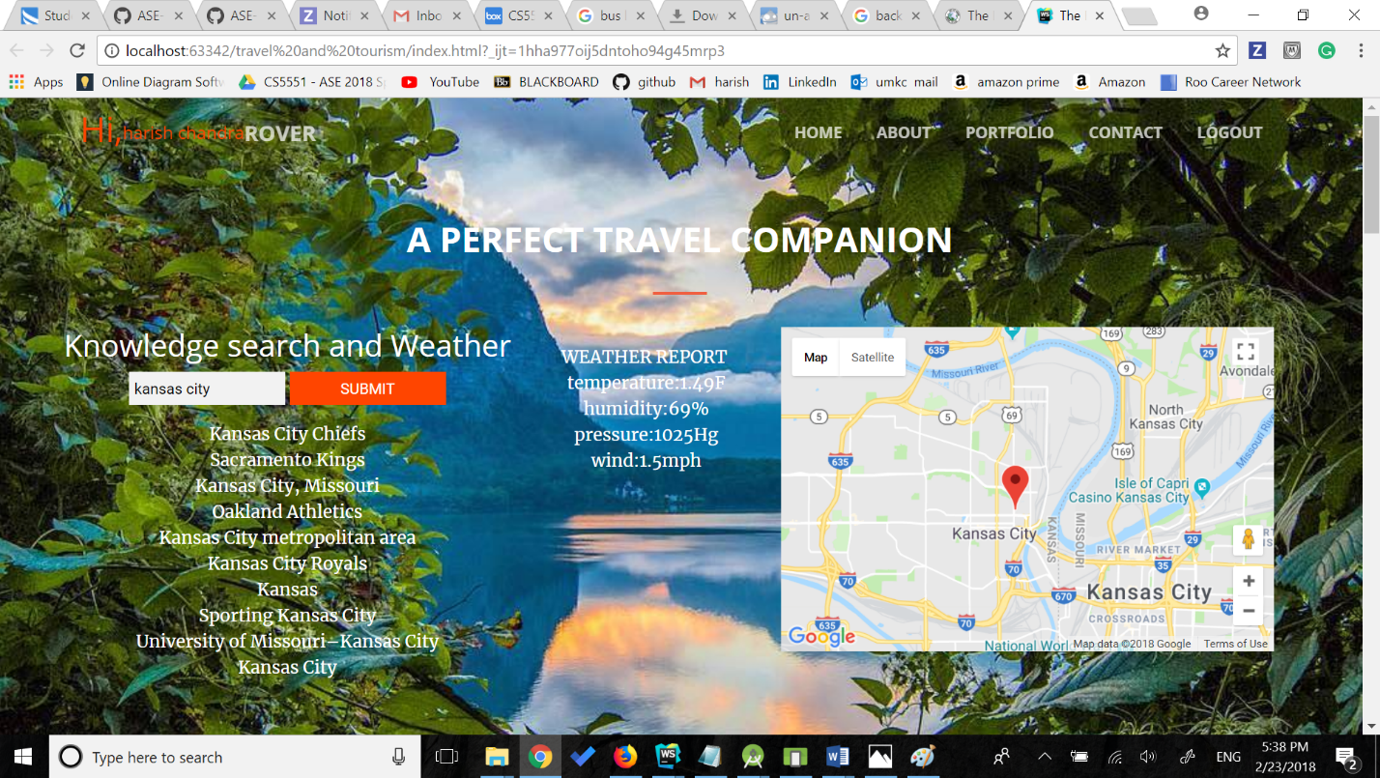

* 1. **Deployment**

**Screenshots of the app deployed into Android Emulator**

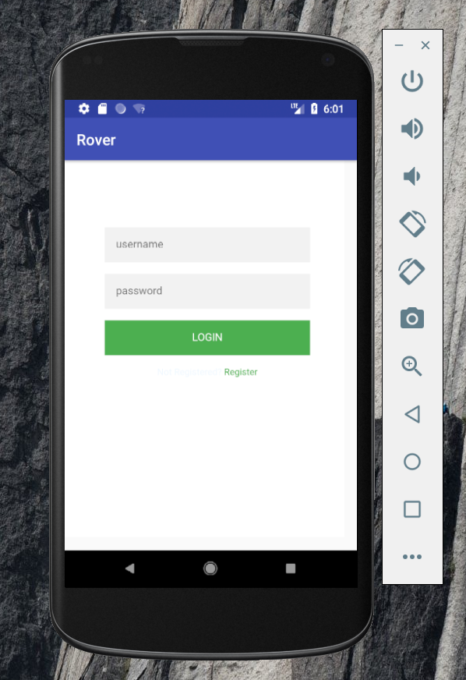

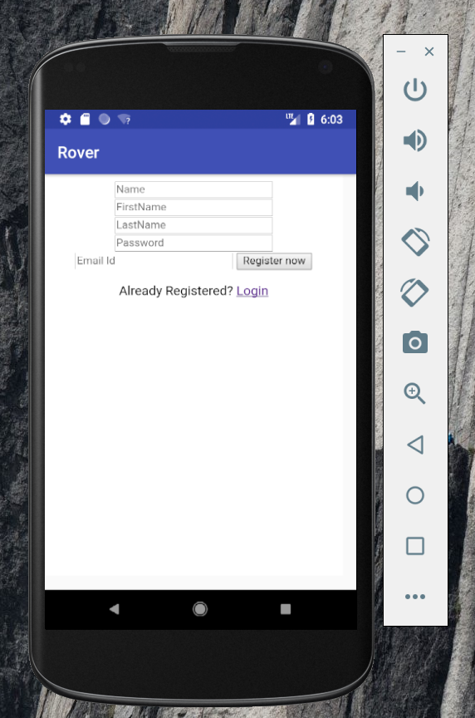

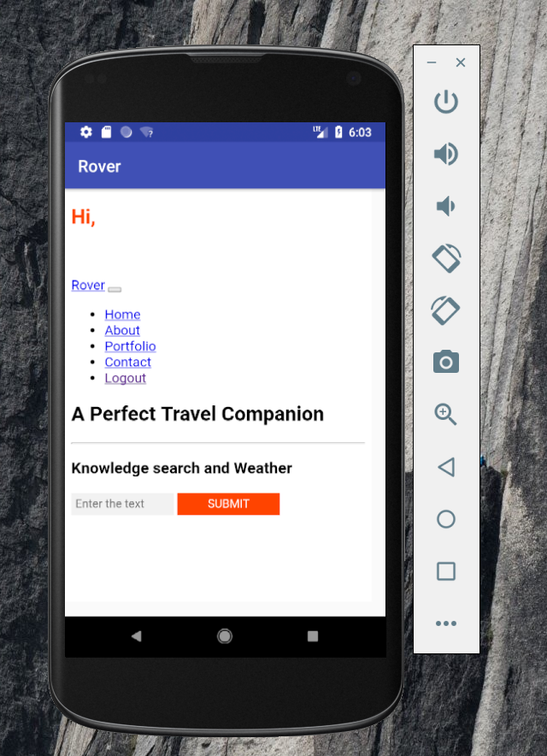

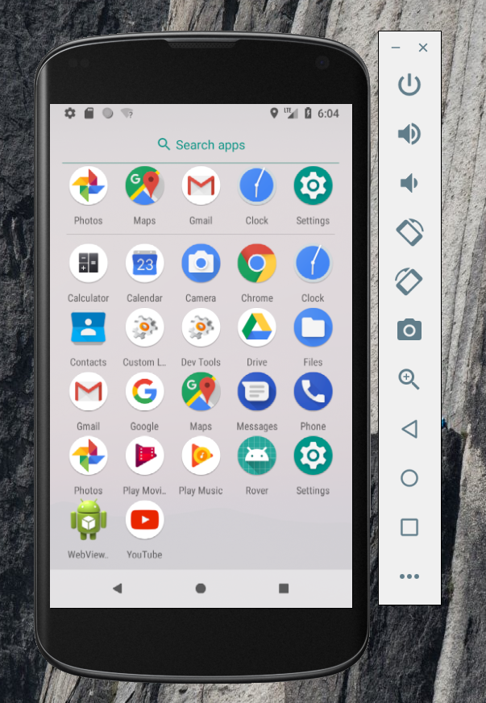

* 1. **Project Management:**

**Following are the screenshots of the Issues and Burndown chart in ZENHUB**

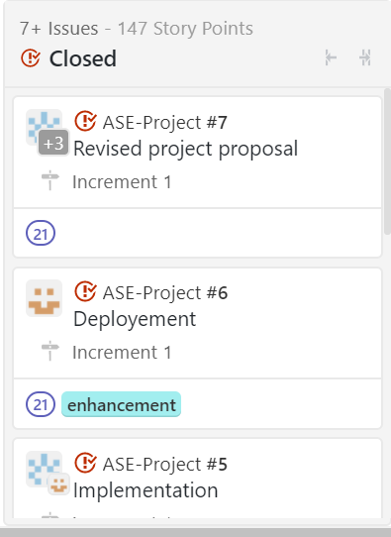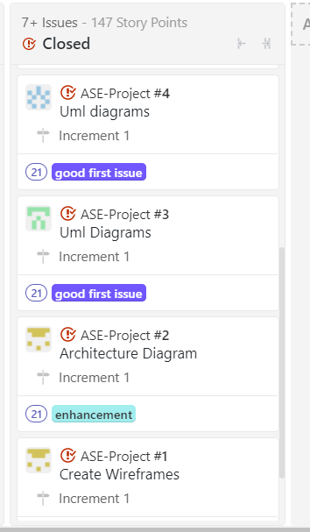

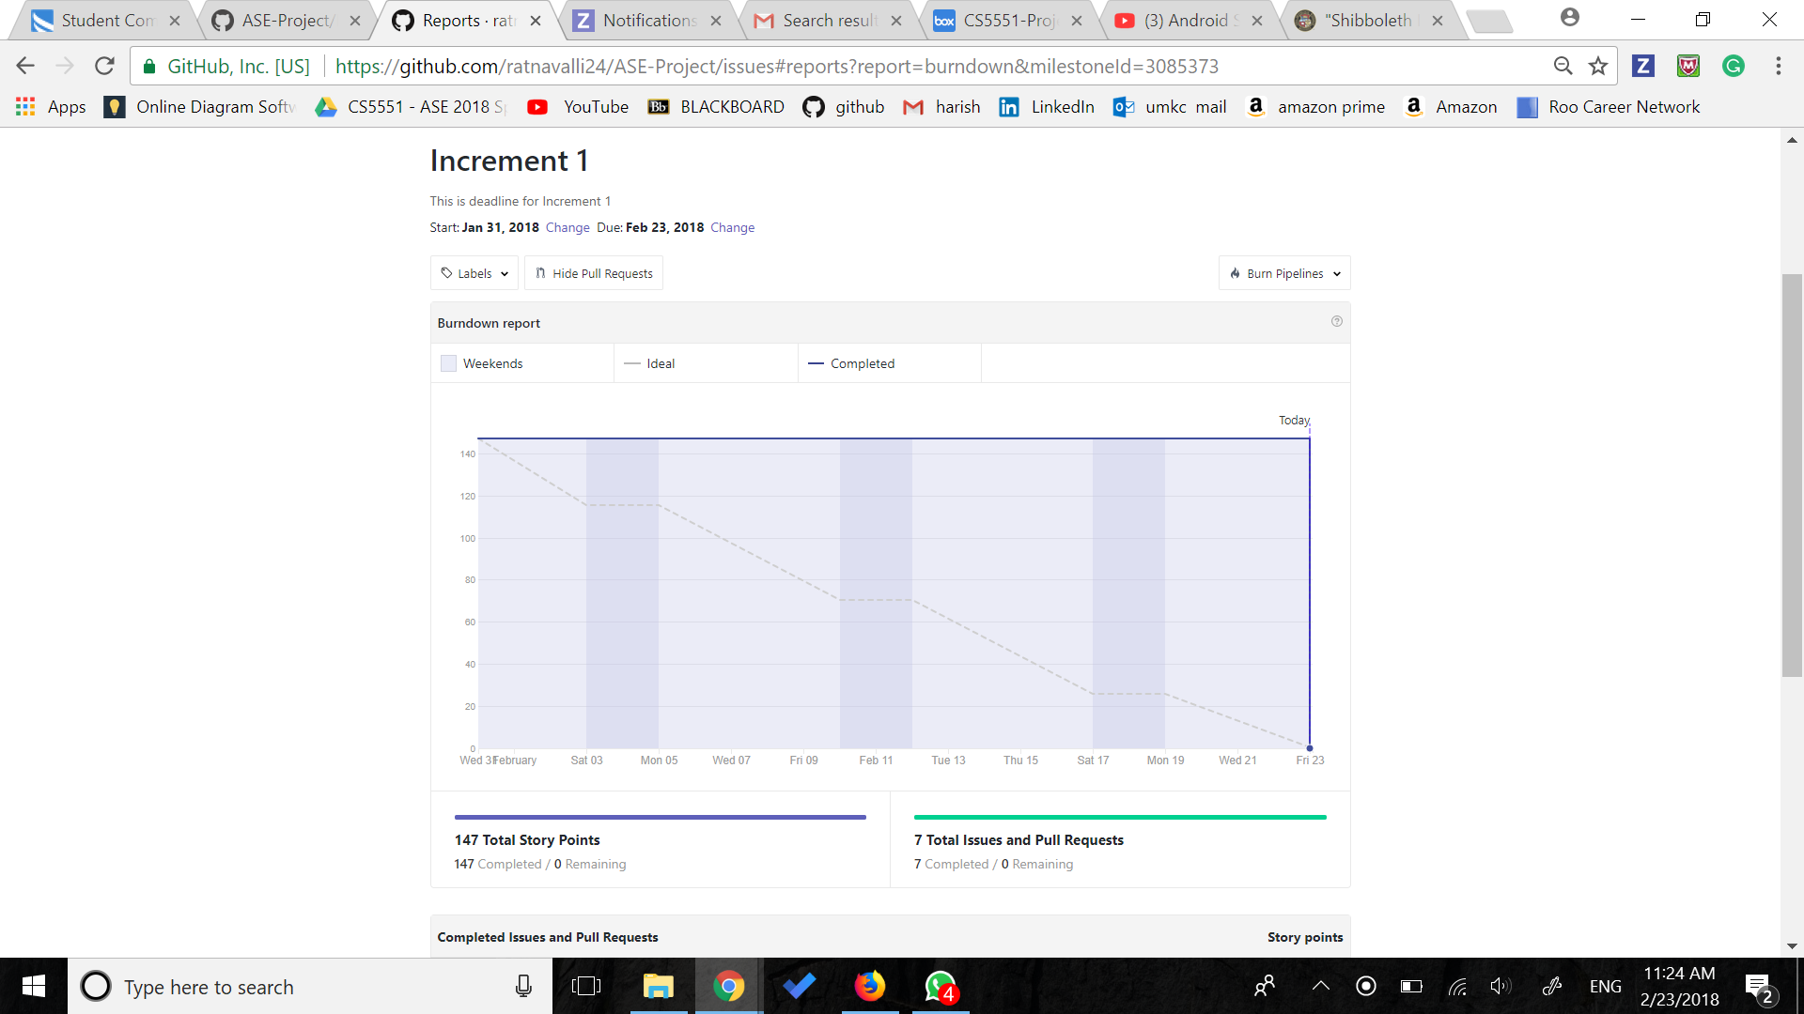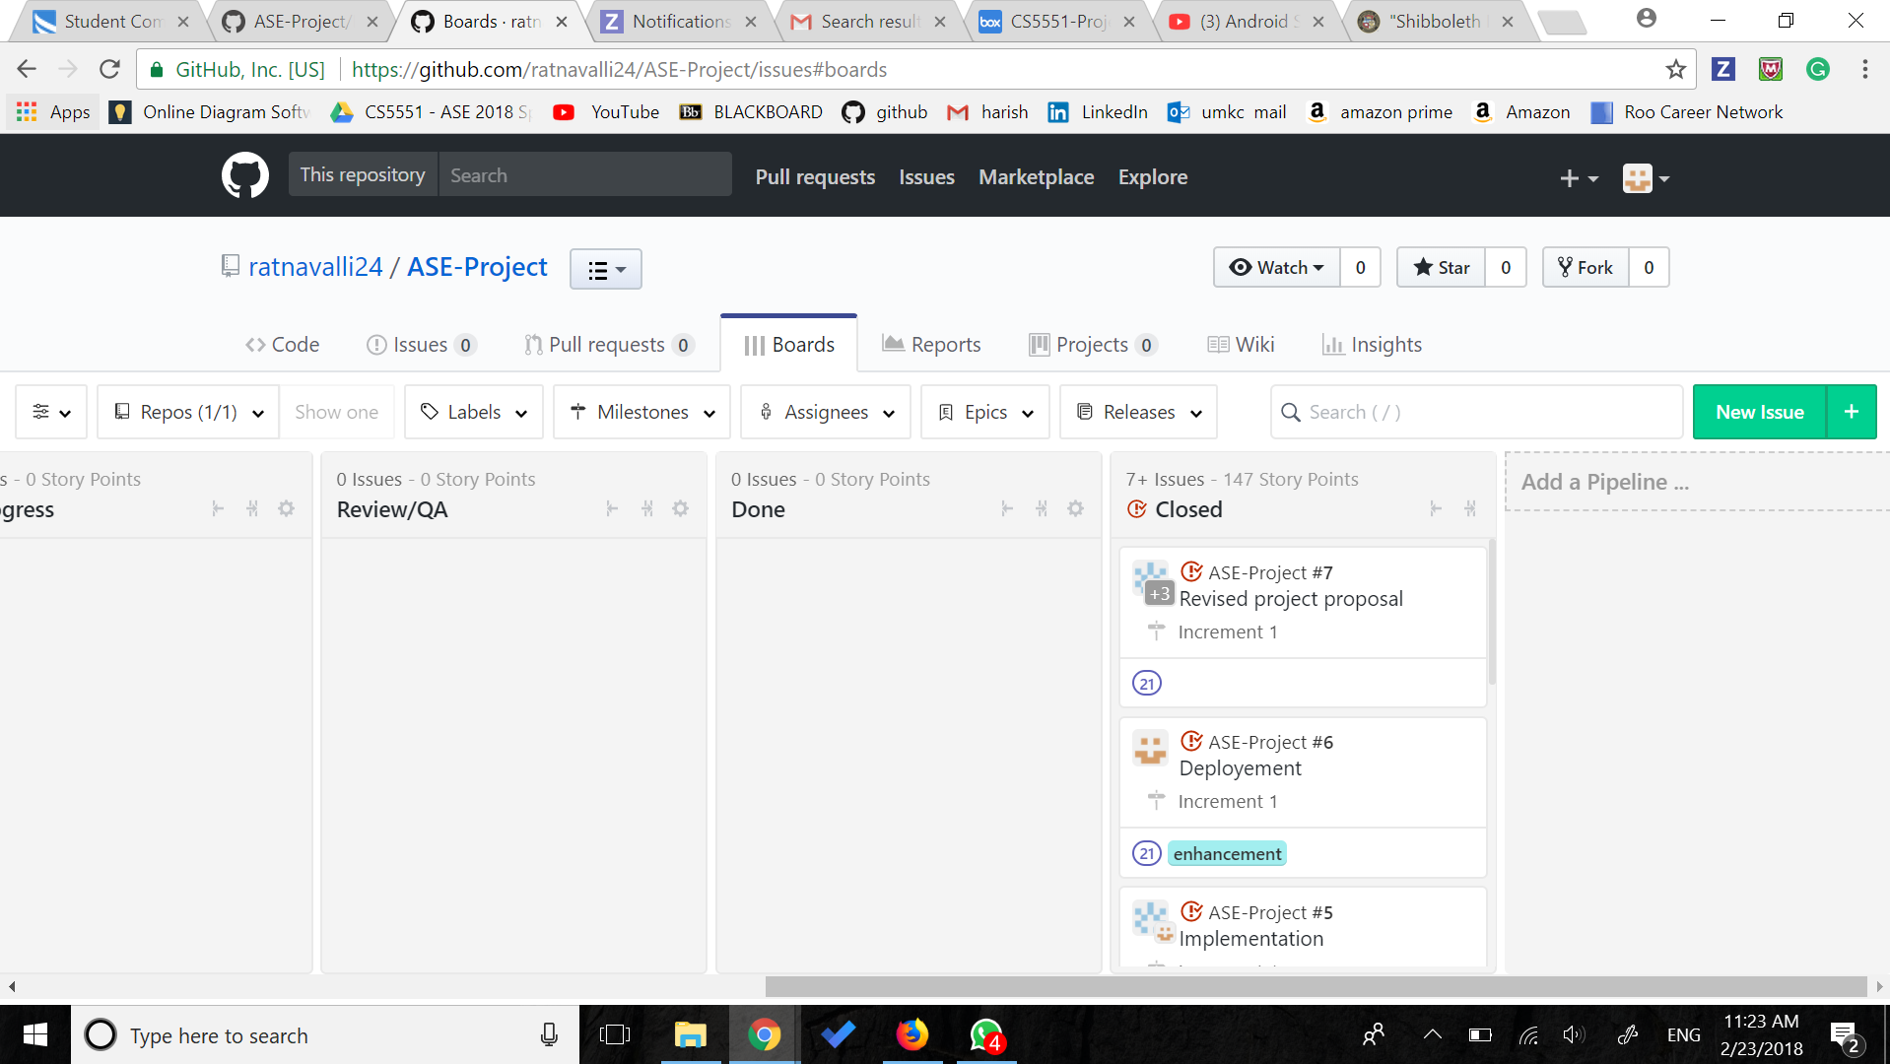

**Work to be Done in ZenHub:**

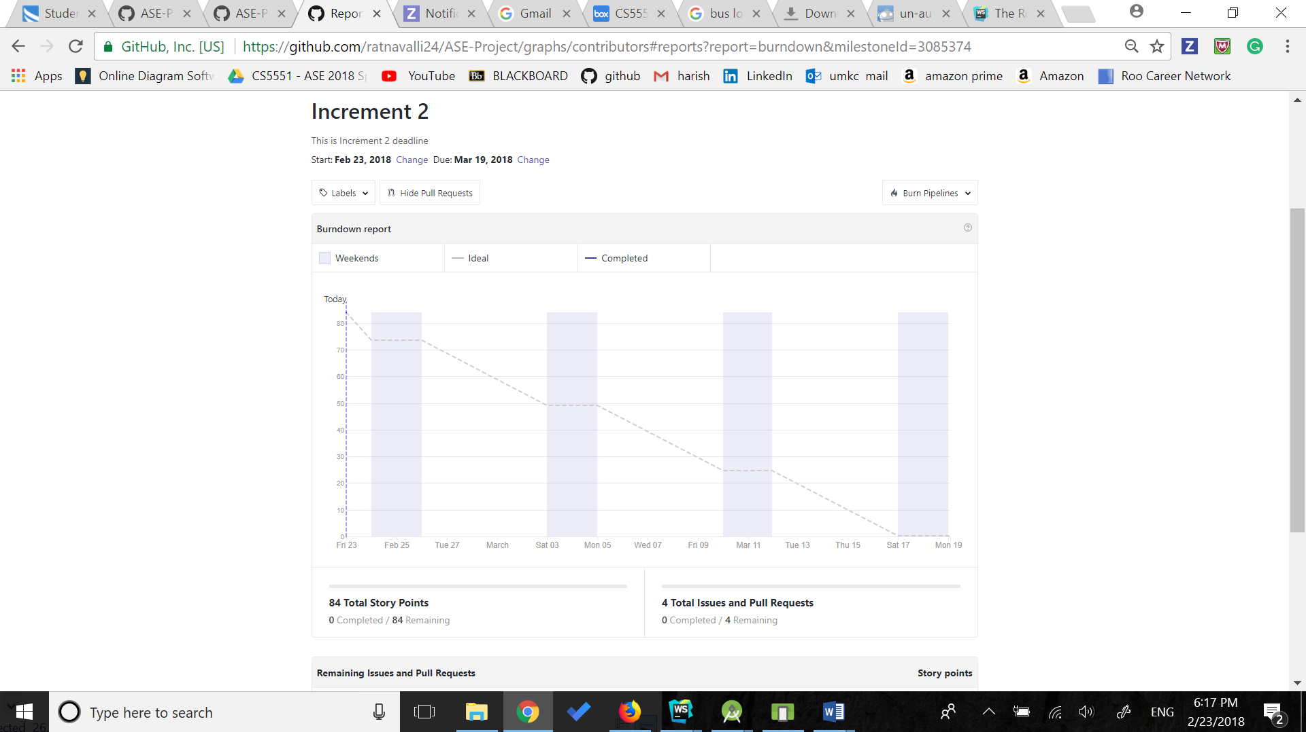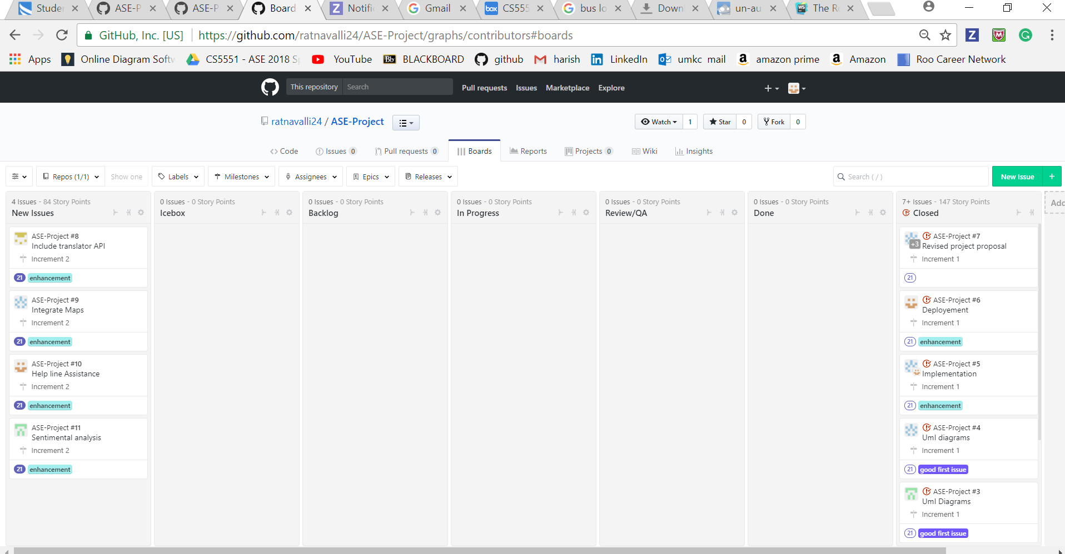

* 1. **Bibilography:**
* <https://stackoverflow.com/questions/5806220/how-to-connect-to-my-http-localhost-web-server-from-android-emulator-in-eclips>
* https://www.creative-tim.com/bootstrap-themes/free